
Certificate of Credit

Memorial Medical Center certifies that
Has participated in the live educational activity titled
2025 New Mexico Osteopathic Medical Association Chile Symposium
at Burrell College of Osteopathic Medicine, Las Cruces, New Mexico
on September 12, 13, & 14, 2025. This live activity was designated for eighteen (18.0) AMA PRA Category 1 Credit(s)TM
Presented by: Alec Baktamian, DO; Afreen Bakht, OMS; Keri Bow, OMS; Stan Carter, DO; Bradley Chuchian, DO; Jon Dadd, DO; Tom Eiting, PhD; Brittany Fisher, DO; Michael Frederich, MD; Oliver Hayes, DO; Robert Hostoffer, DO; Giselle Iro, DO; Andrew Issa, DO; Natalie Nacy, OMS; Katherine Nixon, DO; Andrew Peace, OMS; Bethany Phillips-Smith, DO; Yareli Reyes, OMS; Milo Taylor, OMS; Sydney Taylor; DO; Elizabeth Young, OMS
Accreditations:
Memorial Medical Center (MMC) is accredited by the New Mexico Medical Society (NMMS) to provide continuing medical education for physicians.
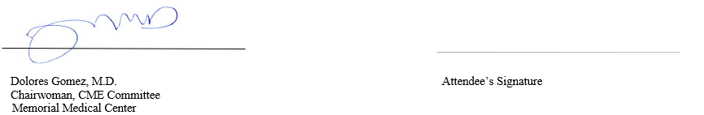
Memorial Medical Center (MMC) designates this live activity for a maximum of 18.0 AMA PRA Category 1 Credit(s)TM. Physicians should claim only the credit commensurate with the extent of their participation in the activity.

