
Certificate of Credit
,
Memorial Medical Center certifies that
(Insert Name Here)
Has participated in the live educational activity titled
Navigating the Substance Use Disorder (SUD) Continuum of Care
at , (location) New Mexico
on Click or tap here to enter text. (date) .
This live activity was designated for Click or tap here to enter text.(number of credits written and numerical) AMA PRA Category 1 Credit(s)TM
Presented by: Click or tap here to enter text.(detailer name and credentials)
Accreditations
Memorial Medical Center (MMC) is accredited by the New Mexico Medical Society (NMMS) to provide continuing medical education for physicians.
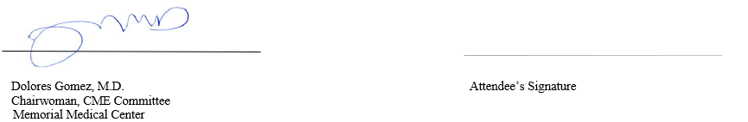
Memorial Medical Center (MMC) designates this live activity for a maximum of 4.0 AMA PRA Category 1 Credit(s)TM. Physicians should claim only the credit commensurate with the extent of their participation in the activity.

